# Visual Desigh HW1

61247001S 蕭瀜

### Data Abstraction and Color

Q1: What type of attribute (categorical, ordinal, quantitative) are the following? If the

attribute is ordinal or quantitative, what is the ordering direction (sequential, diverging, cyclic)? What color map (#1~#6) is the best choice to encode each attribute? (30%)

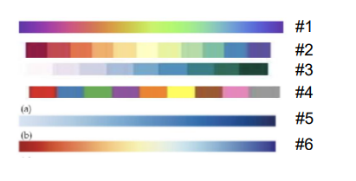

1. Academic letter grade (e.g. A+, A, A-, B+ B …)

Type of attribute: Ordinal

Ordering direction: Sequential

Color map: #3

1. Media companies (e.g. Netflix, Walt Disney, Fox, CBS, …)

Type of attribute: Categorical

Color map: #4

1. Acceleration (e.g. +2 m/s2,-3 m/s2 , +22 m/s2 )

Type of attribute: Quantitative

Ordering direction: Diverging

Color map: #6

1. Scores of an exam (e.g. 90 points, 60 points, 30 points)

Type of attribute: Quantitative

Ordering direction: Sequential

Color map: #5

1. Survey options (e.g., strongly agree, agree, disagree, strongly, disagree )

Type of attribute: Ordinal

Ordering direction: Sequential

Color map: #2

Q2: Check this website about mental health survey: (36%)

<https://www.kaggle.com/datasets/mahirahmzh/starbucks-customer-retention-malaysia-survey>

* Write down the attribute types of the following attributes (categorical, ordinal, quantitative) and explain your choice for every attributes.
  + Id

Type of attribute: Categorical

Explanation: The values has no actual meaning.

* + Gender

Type of attribute: Categorical

Explanation: The value can only be male or female.

* + Age

Type of attribute: Ordinal

Explanation: The values are categorized into 4 types, but there exists a size relationship among them.

* + Status

Type of attribute: Categorical

Explanation: The values can only be 4 different status.

* + Income

Type of attribute: Ordinal

Explanation: The values are categorized into 5 types, but there exists a size relationship among them.

* + visitNo

Type of attribute: Ordinal

Explanation: The values are categorized into 4 types of frequency, but there exists a size relationship among them.

* + Method

Type of attribute: Categorical

Explanation: The values can only be 4 different method.

* + timeSpend

Type of attribute: Ordinal

Explanation: The values are categorized into 5 types, but there exists a size relationship among them.

* + Location

Type of attribute: Ordinal

Explanation: The values are categorized into 3 types, but there exists a size relationship among them.

* + membershipCard

Type of attribute: Categorical

Explanation: The values can only be yes or no.

* + spendPurchase

Type of attribute: Ordinal

Explanation: The values are categorized into 4 types, but there exists a size relationship among them.

* + produceRate

Type of attribute: Ordinal

Explanation: The values are scaled from 1 to 5.

### Visual Channel and Mark:

Q3: You will identify data items and the marks used to encode them, and data attributes and the channels used to encode them. (34%)

For each chart, fill in

* + Visual channels used?
    - Channel X encodes attribute Y
    - Channel X encodes attribute Y
    - ....
  + Marks used?
    - Mark of type X encodes item Y
    - Mark of type X encodes item Y
    - …

Note that underneath each chart there is a link to a web page providing details about the project, including information about the data and in many cases supporting interactivity. For now, just encode what you see in the **static image** in this document; you might notice that interactivity is being used a lot for emphasis (hover highlight, animated transitions, reordering, details popups, small multiples zooming). Think about how you would reconstruct the dataset underlying this picture. Assume one mark per item, think of items as rows of a table (or nodes in a network). Assume each channel is showing an attribute, where channel is a column in a simple data table or network. Remember that multiple channels could redundantly encode the same attribute.

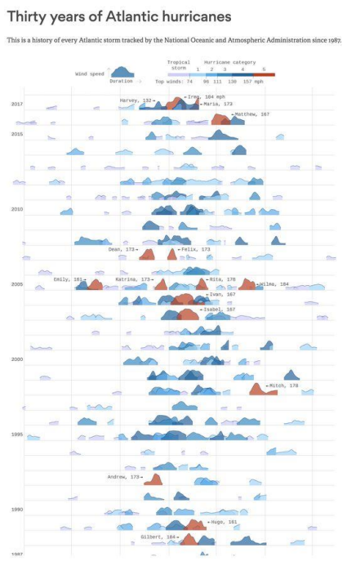

* Visual channels used
  + Channel X (color intensity) encodes attribute Y (top wind speed)
  + Channel X (color hue encodes) attribute Y (hurricane category)
  + Channel X (horizontal span) encodes attribute Y (duration of the storm)
  + Channel X (vertical span) encodes attribute Y (current wind speed of the storm)
  + Channel X (vertical position) encodes attribute Y (year)
* Marks used
  + Mark of type (shape) encodes item (hurricane)

1. [Across U.S. Companies, Tax Rates Vary Greatly - Interactive Feature - NYTimes.com](https://archive.nytimes.com/www.nytimes.com/interactive/2013/05/25/sunday-review/corporate-taxes.html)

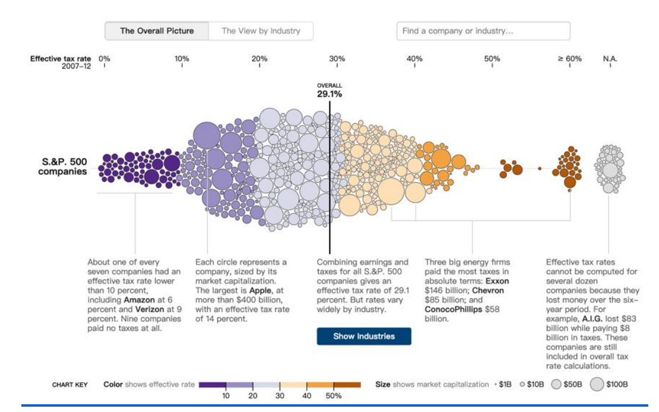

* Visual channels used
  + Channel X (Color intensity) encodes attribute Y (Effective tax rate range)
  + Channel X (Size of circle) encodes attribute Y (Market capitalization)
  + Channel X (Horizontal position) encodes attribute Y (Effective tax rate)
* Marks used
  + Mark of type (Circle) encodes item Y (Individual companies)

1. [2020 Election Forecast | FiveThirtyEight](https://projects.fivethirtyeight.com/2020-election-forecast/)

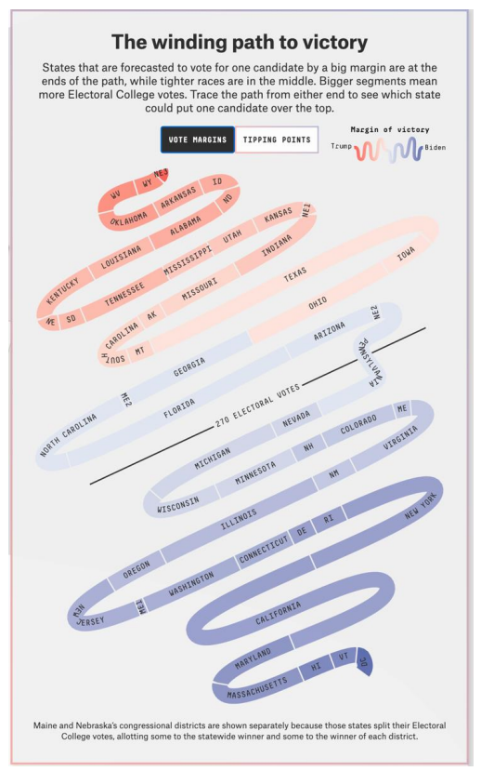

* Visual channels used
  + Channel X (Color intensity) encodes attribute Y (The voting percentages for Trump and Biden)
  + Channel X (Length of path) encodes attribute Y (Electoral college votes)
* Marks used
  + Mark of type (Path) encodes item Y (Election Voting Status by State)
  + Mark of type (Text) encodes item Y (State name)